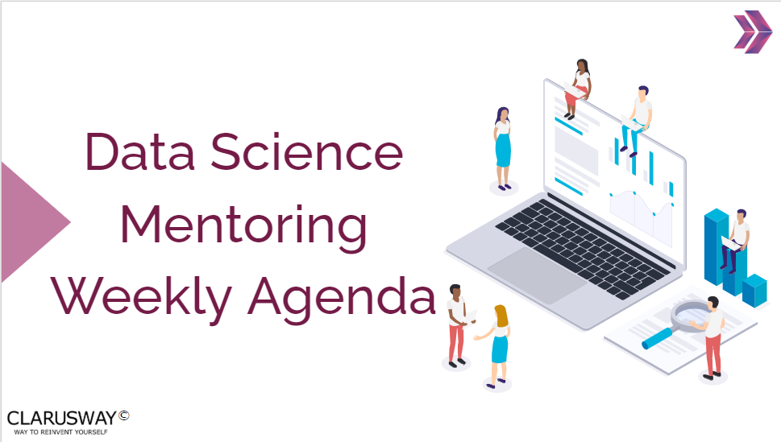

*26 – April – 2022 – Week 1*

**Questions Related to Course Topics**

Problems, interview questions and related course topics within the week or sprint term.

#### Please click the links below and discuss/solve Statistics questions on these pages

* [Individuals, variables, and categorical & quantitative data](https://www.khanacademy.org/math/statistics-probability/analyzing-categorical-data/one-categorical-variable/e/individuals-variables-categorical-quantitative-data)
* [Read bar graphs](https://www.khanacademy.org/math/statistics-probability/analyzing-categorical-data/one-categorical-variable/e/reading_bar_charts_2)
* [Two-way relative frequency tables](https://www.khanacademy.org/math/statistics-probability/analyzing-categorical-data/two-way-tables-for-categorical-data/e/reading-two-way-relative-frequency-tables)
* [Interquartile range (IQR)](https://www.khanacademy.org/math/statistics-probability/summarizing-quantitative-data/interquartile-range-iqr/e/calculating-the-interquartile-range--iqr-)
* [Scatter Plot - Positive/Negative Relation](https://www.khanacademy.org/math/probability/scatterplots-a1/creating-interpreting-scatterplots/e/positive-and-negative-linear-correlations-from-scatter-plots)
* [Scatter Plot - Correlation](https://www.khanacademy.org/math/probability/scatterplots-a1/creating-interpreting-scatterplots/e/correlation-coefficient-intuition)

#### What is sampling? Why do we need it?

#### What is an outlier? Explain how you might screen for outliers and what would you do if you found them in your dataset.

|  |  |  |
| --- | --- | --- |
| **Project Discussion** |  |  |

* Assignment-1 (Python Notebook)(DS 11/22 EU)

|  |  |  |
| --- | --- | --- |
| **FlipGrid Discussion** |  |  |

* FlipGrid 0-Tell me about yourself...